Assignment - 5

You have been asked to:

● Create a new deployment of ansible cluster of 5 nodes

● Label 2 nodes as test and other 2 as prod

● Install java on test nodes

● Install MySQL-server on prod nodes

Use Ansible roles for the above, group the hosts under test and prod

* Created 5 instances i.e., Master, Test1, Test2, Prod1, Prod2
* Copied the id_rsa.pub from Master and pasted that in ssh/authorized_keys folder of Slaves
* Specified the Hosts

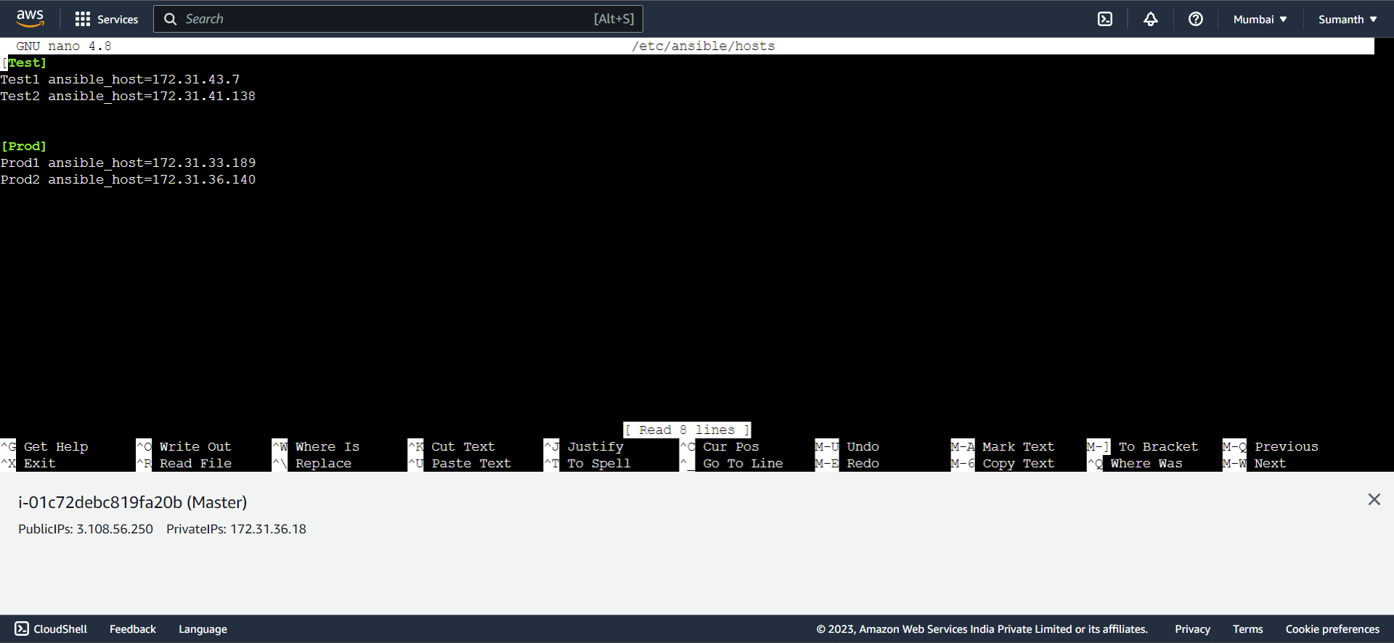

* Created a role for Prod and included in main.yml

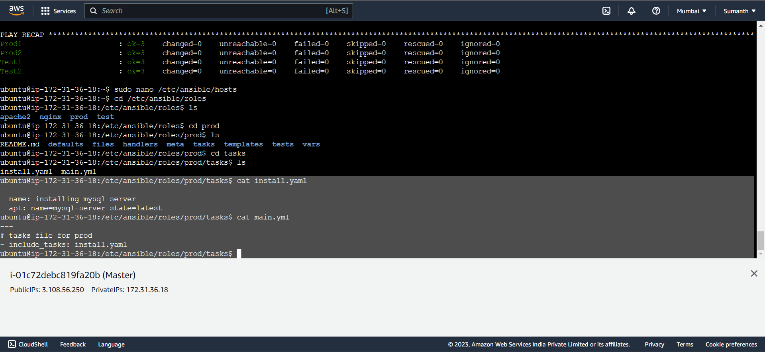

* Created a role for Test and included in main.yml

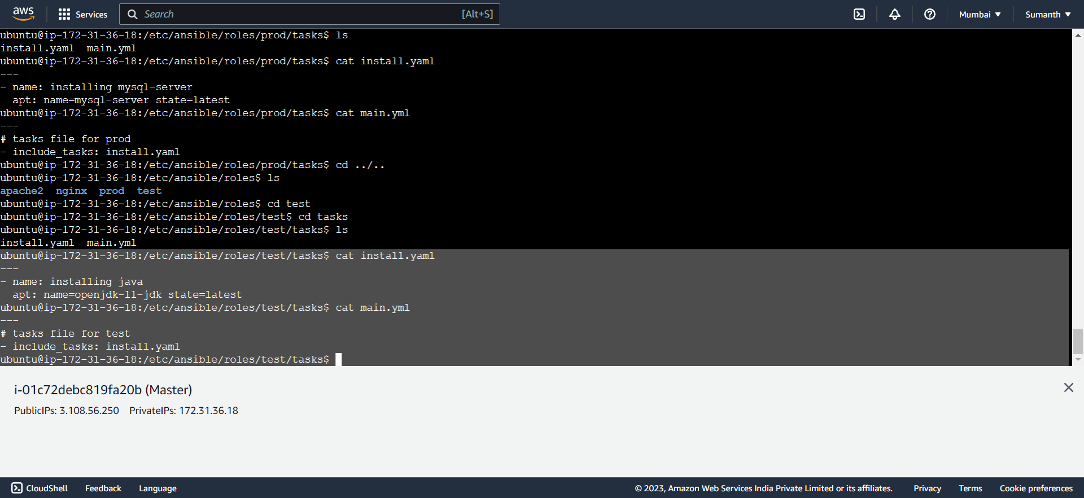

* Specified the Playbook for the task

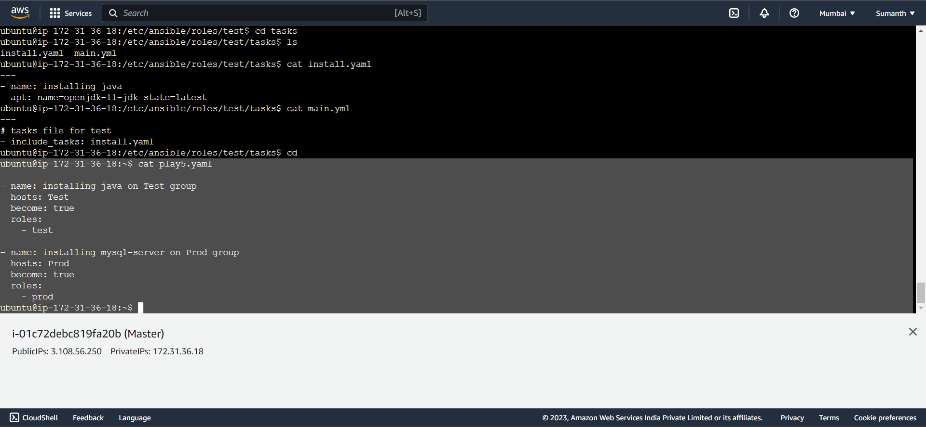

* **Completed the given task by installing Java on Test nodes and MYSQL in Prod nodes**

